7-1 Activity: Data Exploration and Visualization for Insights
Explain the trends, differences, or outliers you observed in the data: The three main transit modes presented are: bus, rail, and ferry; which are broken down into transit type with a two-letter abbreviation, please see Figure 1 for the full names of each transit type. Further different locations can be grouped into city classifications based on their population, please see Figure 2. Trends and differences can be observed on a national, regional (the state of Washington and Oregon), and on a local level (looking that the three neighborhoods: King County, City of Longview, and Spokane Transit Authority, which will be referred to as the three neighborhoods). In 2023, for all active transit types, the large metropolitan areas accounted for 89.8% of total public transit miles on a national level, 85.8% on a regional level, and 89.1% on a location level, please see Figure 3. Although there are similarities in the areas using public transportation, the make-up differs between the levels. In 2023, on a national level bus transit accounted for 50.8% of transit trips, 69.1% on a regional level, and on a local level bus trips accounted for 98% of total public transit trips, please see Figure 3. The use of public transit has increased substantially at a national and regional level in comparison between 2021 and 2023, please see Figure 3.
Describe any disparities or patterns that may be relevant to the nonprofit's goals: Upon examining the average cost per mile of transportation per transit mode (bus, rail, and ferry) the average cost for these three neighborhoods exceeds the regional average, please see Figure 4. The difference in bus cost is not significant, 13% higher, however the difference becomes more pronounced for ferry transit, 39% higher, and significantly higher for rail transit, 54% higher.
Write a summary of what the data suggests about transit usage across neighborhoods: Since there is a significant difference in the population size of the three neighborhoods in 2023, Seattle/Tacoma, WA (3,544,011); Spokane, WA (447,379), and Longview,WA/OR (69,841), each represents a different type of city and should therefore not necessarily be compared with each other but with other cities of a similar size within a similar region. Therefore, the information for King County (Seattle/Tacoma, WA) was compared with the data for the Tri-County Metropolitan Transportation District of Oregon, the information for the Spokane Transity Authority (Spokane, WA) was compared with that data for the Lane Transit District, and the information for the City of Longview (Longview,WA/OR) was compared with the data for Skagit Transit, please see Figure 5. In looking at the service area population in comparison to the neighborhood population, the percentages for all three neighborhoods are below those of their comparative neighborhoods, please see Figure 6. Additionally, any bars extending above the red line serve a transit population that exceeds their neighborhood population. Another relevant comparison factor is the average cost per mile for the three neighborhoods versus their comparison neighborhoods. Since bus transit accounts for most of the transportation in the three neighborhoods, 98% of all transit trips, the analysis will focus on the bus transit mode. The data indicates that for bus transit in 2023, the City of Longview and Spokane Transit Authority’s cost per mile exceeded their comparison neighborhoods, by 47% and 41% respectively; while the King County’s cost per bus was 26% lower, please see Figure 7. In examining the underlying transit types for the bus transit mode, the Demand Response (DR) bus type has a significantly higher cost per mile than other bus types (Bus, Trolleybus, and Vanpool) across all three neighborhoods and is the only transit type that exceeds the regional average cost per mile, please see Figure 8.
Explain how the visualizations support your conclusions: The visualizations presented allow for the nonprofit user to easily see the patterns present in the information and allows for them to visually make comparisons between the three neighborhoods, their comparison neighborhoods, and the regional data. The figures presented start at a broader level and progressively provide more detailed information. This allows the audience to be able to grasp these details by having a solid understanding of the patterns being seen at a national and regional level.
Discuss how your findings could inform the nonprofit’s decision making or strategy: The information outlined above would allow a nonprofit organization to be aware of trends in public transportation at the national, regional, and local level and to be able to determine how the new public transit available in the three neighborhoods is performing in terms of servicing the population and the average cost per mile of travel. Additionally, the information provides a basis for the development of improvement goals for each transit mode as well as the transit types that need to be focused on regarding methods of reducing operating expenses and the neighborhoods that need to increase their population service capacity.
Describe the importance of data-driven insights in addressing real-world challenges: This example demonstrates the importance of utilizing data to gain insight into real-world scenarios. Given the size of the dataset without the process of data analysis and the creation of summaries and graphs, it would be difficult to gain a holistic understanding of the changes being seen in the public transportation industry. Additionally, this example demonstrates the importance of utilizing proper benchmarking information like regional data and similar neighborhoods for comparison purposes so that the comparison is made between similar transit types based on location, public transit modes available, and population. This allows for the identification of specific areas to focus on so that attention can be paid to targeted segments that will improve the overall bottom-line for a nonprofit public transportation organization. For example, the King County neighborhood should focus on increasing their service population and the City of Longview should focus on reducing Demand Response bus costs per mile.

References
FTA. (n.d.). National Transit Database (NTD) Glossary. Retrieved from Federal Transit Administration: https://www.transit.dot.gov/ntd/national-transit-database-ntd-glossary
OECD. (n.d.). Urban population by city size. Retrieved from OECD: https://www.oecd.org/en/data/indicators/urban-population-by-city-size.html

Figures
Figure 1: Transit Abbreviation Type Meaning
Abbreviation | Transit Type | Transit Mode
DR | Demand Response | Bus
FB | Ferryboat | Ferry
LR | Light Rail | Rail
MB | Bus | Bus
SR | Streetcar Rail | Rail
TB | Trolleybus | Bus
VP | Vanpool | Bus
CB | Commuter Bus | Bus

Figure Source: (FTA, n.d.)

Figure 2: City Classification based on Population Size
City Type | Minimum Population | Maximum Population | Neighborhood
Small Urban Area | 50,000 | 200,000 | City of Longview
Medium-Size Urban Area | 200,000 | 500,000 | Spokane Transit Authority
Metropolitan Area | 500,000 | 1,500,000
Large Metropolitan Area | 1,500,000 | None | King County

Figure Source: (OECD, n.d.)

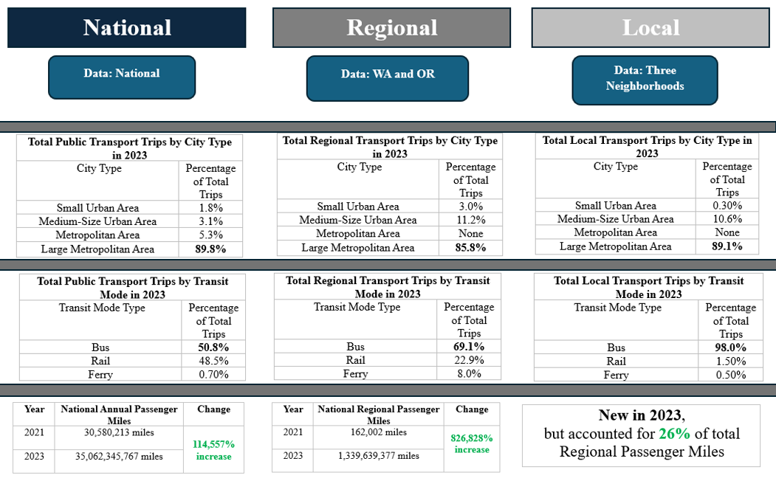
Figure 3: National, Regional, and Local Public Transit Summary

Figure 4: Comparison of Average Cost per Mile per Transit Mode Type (Regional vs. Neighborhood)
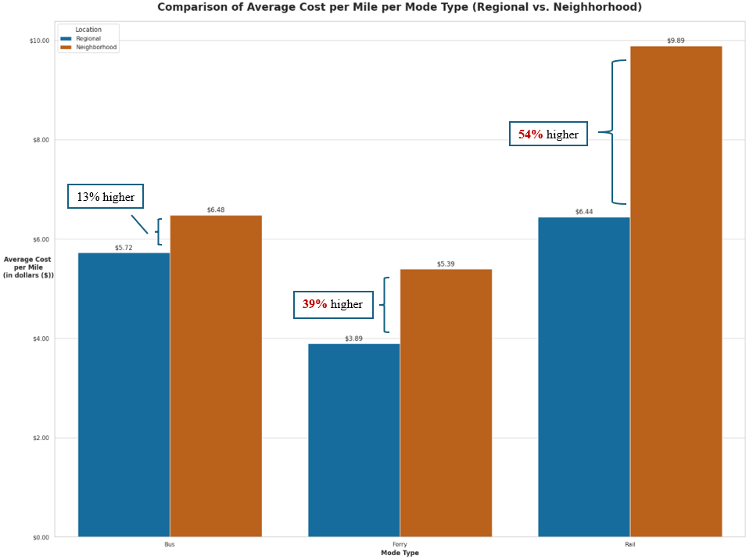

Figure 5: Neighborhood Comparison Information
 | King County | Tri-County Metropolitan Transportation District of Oregon
Area Served | Seattle--Tacoma, WA | Portland, OR--WA
2023 Population | 3,544,011 | 2,104,238
2023 Transit Service Population | 2,347,800 | 1,512,100

 | Spokane Transit Authority | Lane Transit District
Area Served | Spokane, WA | Eugene, OR
2023 Population | 447,279 | 270,179
2023 Transit Service Population | 471,169 | 317,600

 | City of Longview | Skagit Transit
Area Served | Longview, WA--OR | Mount Vernon, WA
2023 Population | 69,841 | 66,825
2023 Transit Service Population | 61,598 | 118,568

Figure 6: Service Areas as a Percentage of the Neighborhood Population
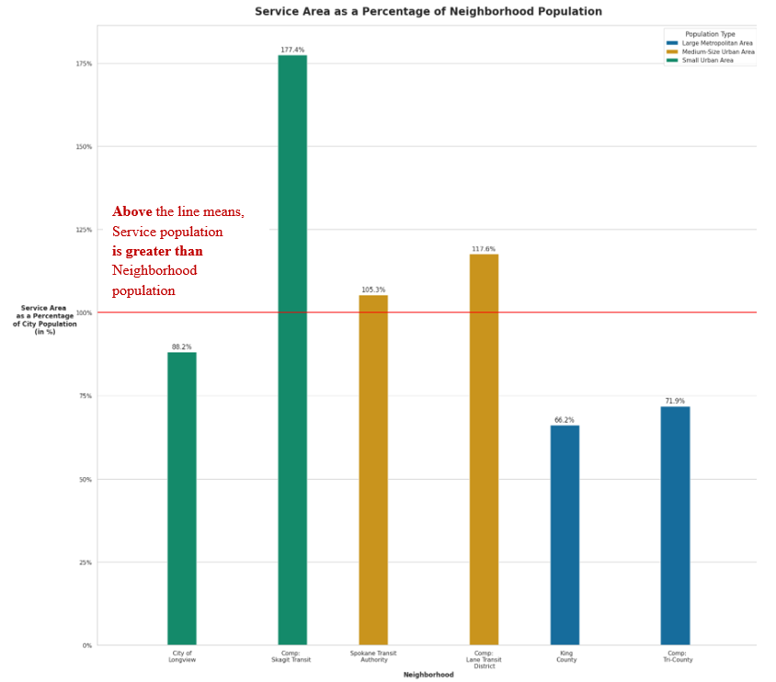

Figure 7: Cost per Bus Mile Comparison between Neighborhoods
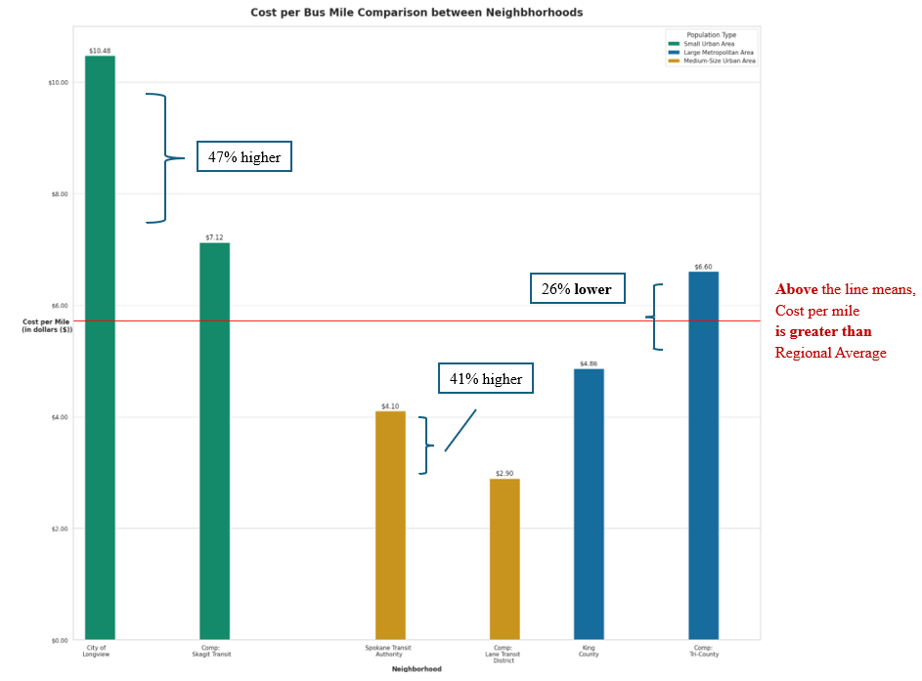
Figure 8: Cost per Bus Mile Comparison between Transit Types
